Monitoring / On-Call Approval Form

Employee Name: Nikunj Adhaduk _

Manager Name: Yaser Shadmehr
.
Monitoring Hours
Date of Monitoring (mm/dd/yyyy) | Project | Reason | Number of Hours
TOTAL

On-Call Payment
Dates On-Call (mm/dd/yyyy – mm/dd/yyyy) | # of Weeks | Rate
1/25/2026 – 1/31/2026 | 1 | 200
2/15/2026 – 2/21/2026 | 1 | 200
2/22/2026 – 2/28/2026 | 1 | 200
3/01/2026 – 3/07/2026 | 1 | 200
TOTAL |  | 800
Approvals
Employee Signature: 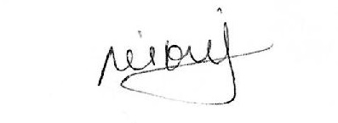 | Date:  March 17, 2026
Manager Signature: | Date:  March 17, 2026

Please submit to Payroll once approved.

Description
Date of Monitoring | Hours | Reason
Jan 28, 2026 | 2 | Not at the time of deployment but after hour support for big BNS tangerine deployment few days before due to database flag datatype changes
Feb 18, 2026 | 7 | Scene big deployment for shell
Feb 25, 2026 | 1.5 | CR-19744 - Rel.2026.02.25
March 6, 2026 | 2.5 | BNS Hotfix deployment for API log backlogs

